**1. Auto Trace & Explain Plan**

1.1 Task 1: Auto Trace configuration training

|  |  |  |  |
| --- | --- | --- | --- |
| № | Auto Trace Configuration Options | Expected Results | Description |
| 1 | set autotrace off | Result datasetonly | Shows only result set of the query |
| 2 | set autotrace on | Result dataset+executionplan+statistics | Shows result set, execution plan and statistic of the query |
| 3 | set autotracetraceonly | Number of selected rows+ execution plan+statistics | Shows number of the rows in result set and execution plan with statistics of the query |
| 4 | set autotrace on explain | Result dataset+ execution plan | Shows result set and execution of the query |
| 5 | set autotrace on statistics | Result dataset+ statistics | Shows result set and statistic of the query |
| 6 | set autotrace on explain statistics | Result dataset+executionplan+statistics | Shows result set, execution plan and statistic of the query |
| 7 | set autotracetraceonly explain | Execution planonly | Shows execution plan only |
| 8 | set autotracetraceonly statistics | Statisticsonly | Shows statistics only |
| 9 | set autotracetraceonly explain statistics | Execution plan+ statistics | Shows execution plan and statistics of the query |
| 10 | set autotrace off explain | Result dataset only | Shows result set only |
| 11 | set autotrace off statistics | Result dataset only | Shows result set only |
| 12 | set autotrace off explain statistics | Result dataset only | Shows result set only |

**2. Join Methods**

2.1 Task 2: Nested Loops Joins

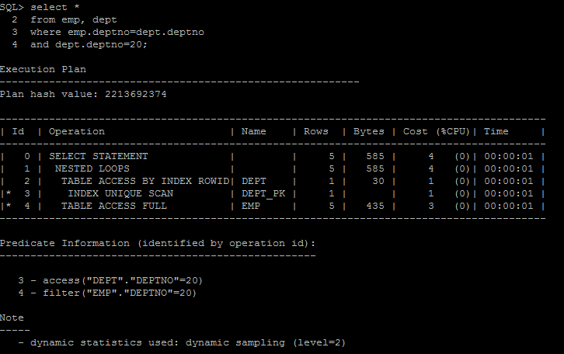

2.2 Task 3: Sort-Merge Joins

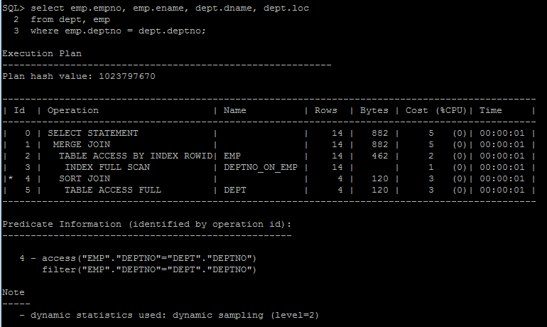

2.3 Task 4: Hash Joins

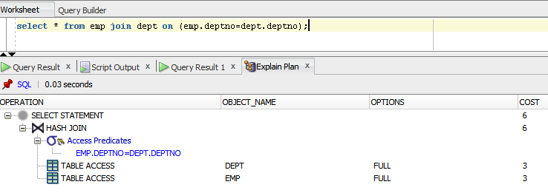2.4 Task 5: Cartesian Joins

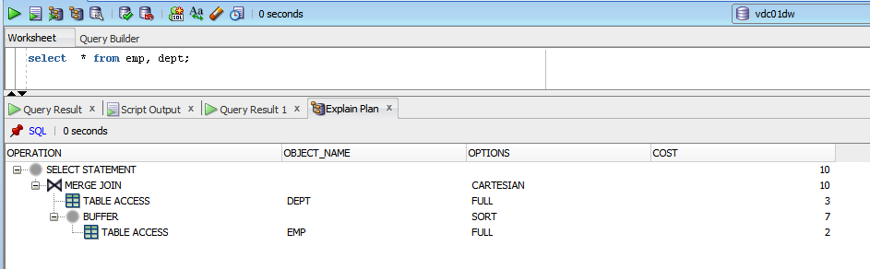

2.5 Task 6: Left/Right Outer Joins

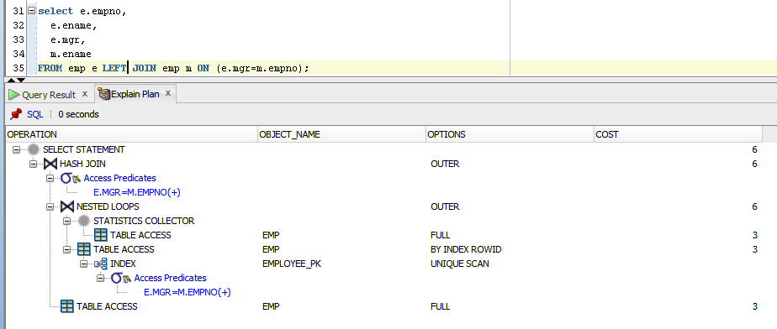

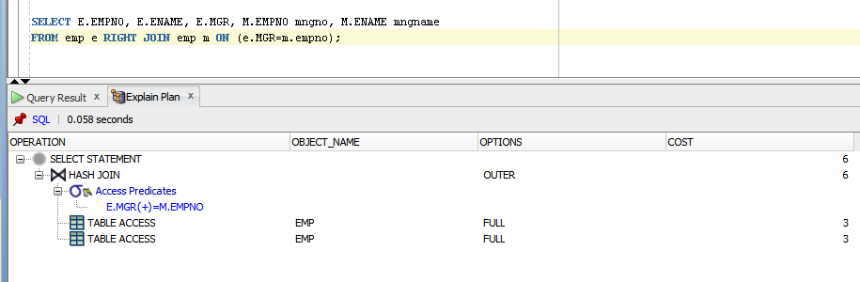

2.6 Task 7: Full Outer Join

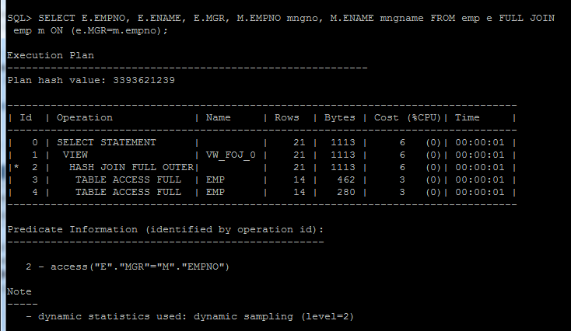

2.7 Task 8:Semi Joins

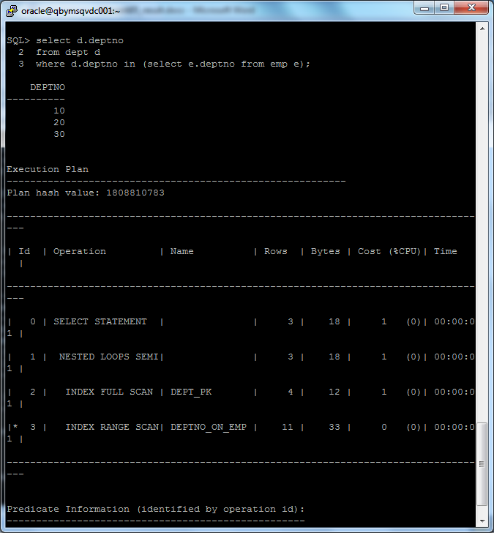

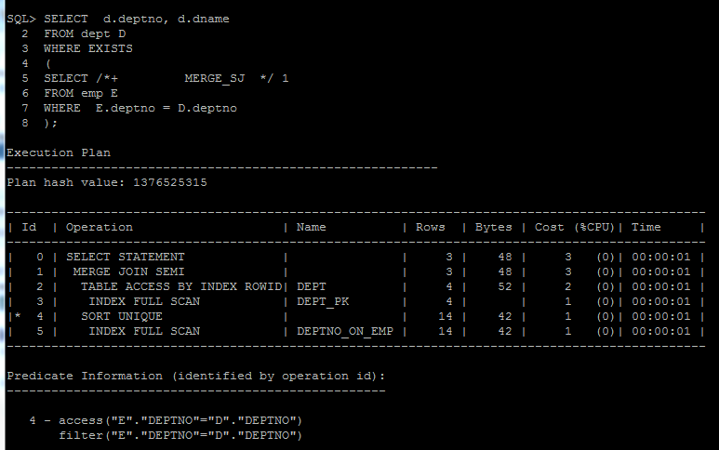

2.8 Task 9: Anti Joins

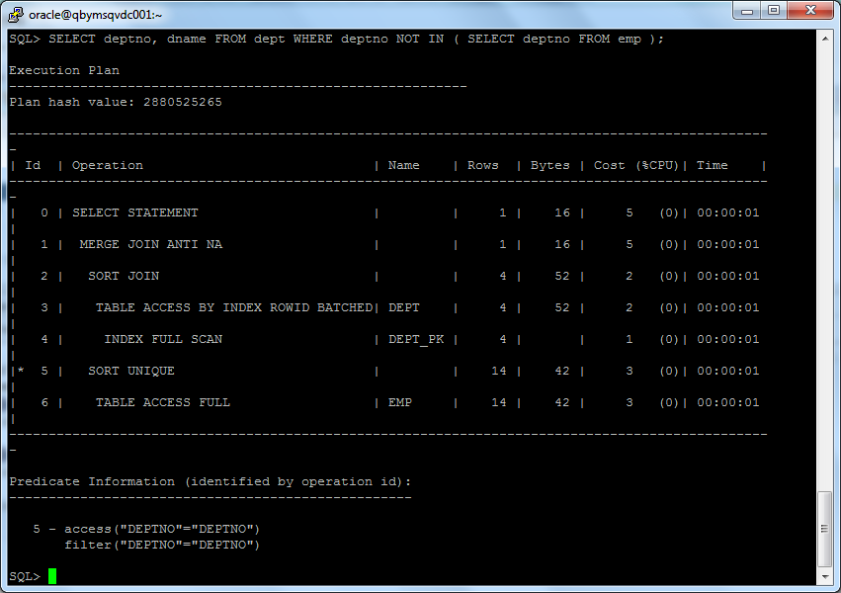

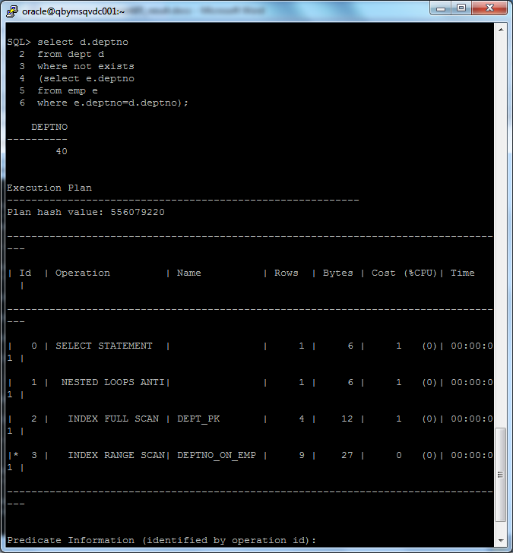

## 2.9 Task 10: Prepare summary table

|  |  |  |  |  |  |  |
| --- | --- | --- | --- | --- | --- | --- |
| Join Access “A” | Join Access “B” | Nested Loop | Hash Join | Sort-Merge Join | Anti-Join | Semi-Join |
| Small Table | Small Table | + + + + | + + + + | + + + + | + + + + | + + + + |
| Small Table | Indexed Small Table | + + + + | + + + + | + + + | + + + + | + + + + |
| Small Table | Big Table | + + | + + + + | + + | + + + | + + + |
| Small Table | IndexedBig Table | + + + | + + + + | + + + | + + + | + + + |
| Big Table | Indexed Small Table | + + | + + + + | + + + | + + + | + + + |
| Big Table | Big Table | + | + + | + | + | + |
| Big Table | IndexedBig Table | + + | + + | + + + | + | + |
| Indexed Small Table | Indexed Small Table | + + + + | + + + + | + + + + | + + + + | + + + + |
| IndexedBig Table | Indexed Small Table | + + + | + + + + | + + + + | + + + | + + + |
| Indexed Big Table | Indexed Big Table | + + + | + + | + + + + | + | + |